
AUDISANKARA INSTITUE OF TECHNOLOGY
An Autonomous institute Affiliated to JNTUA, Accredited by NBA and NAAC
With A
grade
NH 5 Bypass road,Gudur
-
524101
, Tirupathi (DT
)
Name of the Programme
:

BACHELOR OF TECHNOLOGY
Name of the Course
:

COMMUNITY SERVICE PROJECT
Course code
:

20
EC
510
Title of the CSP:
ASSISTANCE TO FARMERS
Year and semester
:

III YEAR | V SEMESTER
Name of the Student
:

JAMPALA THARUN KUMAR
Roll No
:

222H1
A0478
Department
:

ELECTRONICS AND COMMUNICATION ENGINEERING


ASSISTANCE TO FARMERS


Objective:
The objective of assistance to farmers is to support and enhance
their ability to produce food and other agricultural products sustainably and
profitably.

Importance:
In essence, helping farmers helps
bulid

resilient economies,
secure food systems, and healthy environments, all of which are essential
for both local and global well
-
being.

Goal:
The primary goal of assistance to farmers is to improve agricultural
productivity and sustainability, while ensuring viability food security, and
environmental health.

Project overview

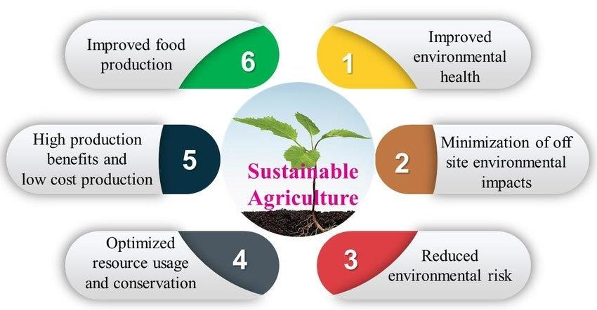
Sustainable to Assistance to Farmers



Various types of Assistance to farmer
1
. Financial Assistance
:

Government or organizations provide direct financial support to reduce the
cost of inputs like seeds, fertilizers, machinery, or water for irrigation.
Access to affordable loans for purchasing farming equipment, improving
infrastructure, or expanding production capacity.

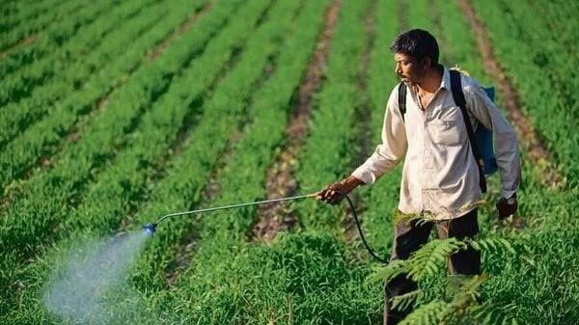
2
. Technical Assistance
Training and Education
:
Extension services offer technical advice and
training on best farming practices, pest control, crop rotation, sustainable
agriculture, and new agricultural technologies.
Research institutions and universities work on developing high
-
yielding,
drought
-
resistant, or pest
-
resistant crops that are suitable for local conditions.


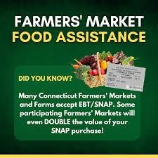
3
. Market Access and Trade Support
Market Linkages
:
Some programs help farmers connect with markets,
cooperatives, processors, or export channels, reducing middlemen and
ensuring fair prices.


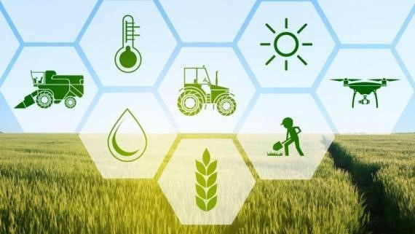
4
. Policy Advocacy
Farmer Representation
:
Farmers' associations and cooperatives can play a
key role in lobbying for better policies, subsidies, or protections that benefit
the agricultural sector.

5. Labor and Capacity Building
Labor Force Support: Programs that help farmers access labor or train local workers in modern farming techniques.
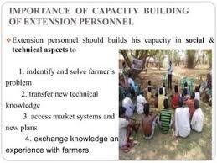

Assistance To Farmers strategies
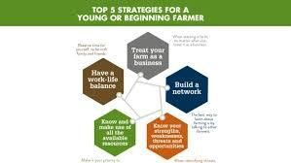
Assistance To Farmers Strategies

1. Promoting Financial Inclusion and Support
Microfinance and Low-Interest Loans: Providing farmers with access to affordable credit is critical. This can be done through microfinance institutions or government-backed low-interest loan programs that allow farmers to invest in inputs, machinery, and infrastructure.

2. Access to Technology and Innovation
Extension Services: Extension services play a vital role in spreading knowledge about new farming techniques, disease management, and sustainable practices. This can include both on-the-ground visits by experts and digital platforms for remote learning.

3. Enhancing Market Access
Market Linkages: Establishing platforms (physical or digital) that connect farmers directly to consumers, cooperatives, or processors can help reduce the reliance on middlemen, ensuring farmers get better prices for their produce.

Measuring And Reporting Performance
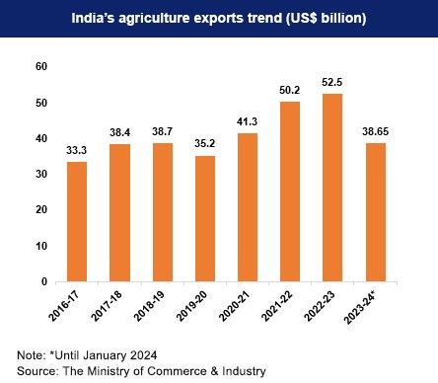
Measuring and Reporting Performance
Setting Clear Objectives and Indicators
Before measuring and reporting performance, it’s crucial to define the goals of the assistance program and establish key performance indicators (KPIs) to track progress.
Data Collection and Monitoring
Regular data collection is essential for tracking performance and ensuring that the assistance program is on track to meet its goals. The data collection process should include:
Baseline Data: Collecting initial data on the conditions before the intervention. For example, baseline income levels, crop yields, or farm practices. Reporting Results
Once performance has been measured and assessed, it needs to be communicated clearly to stakeholders. Effective reporting should:
Provide Clear and Actionable Insights: Share not only what worked but also what didn’t, and why. This helps identify areas for improvement and future strategies.
Use Data Visualization: Presenting data through charts, graphs, and tables makes the results easier to understand and more compelling. Maps, bar charts, and line graphs can help depict trends over time, such as changes in yield or income.

Conclusion
In conclusion, assistance to farmers plays a pivotal role in enhancing agricultural productivity, improving livelihoods, and fostering rural development. The support provided through financial aid, technical training, access to markets, infrastructure development, and sustainable farming practices is essential for empowering farmers to face the challenges of modern agriculture, including climate change, market volatility, and resource constraints.

To be effective, these assistance programs must be well-designed, targeted, and adaptable to the specific needs of different farming communities, whether smallholder farmers or larger commercial operations. Measuring and reporting the performance of these interventions is critical to understanding their impact, ensuring accountability, and guiding future improvements. Transparent reporting and feedback loops also allow for continuous learning and refinement, helping programs evolve in response to farmers’ changing needs and emerging challenges.


Thank You

